ANALYSIS OF STUDENTS' MATHEMATICAL CONCEPT UNDERSTANDING ABILITY IN THE MATERIAL
OF INTEGER NUMBERS

Nanda Fatira Dwi Yanti¹, Adi Ihsan Imami²

^{1*.2}University of Singaperbangsa Karawang, Karawang, Indonesia
*Corresponding author. Singaperbangsa University Karawang, 41361, West Java, Indonesia.

E-mail: | 2110631050087@student.unsika.ac.id¹
 | adi.ihsan@fkip.unsika.ac.id²

Received February 02, 2025; Received in revised form February 19,2025; Accepted March 15, 2025

ABSTRACT
This study aims to analyze students' mathematical concept understanding ability in solving problems on integers. The research subjects were using purposive sampling technique, grade VII students at a Public Junior High School in Karawang Regency. The research instrument consisted of three descriptive questions that measured three indicators of conceptual understanding, namely translation (changing the form of a story problem into a mathematical equation), interpretation (giving meaning to the results of calculations), and extrapolation (concluding the results obtained from previous calculations). Data were collected through written tests and analyzed using data reduction, data presentation, and conclusion drawing techniques. The results showed that students with high abilities met all three indicators of mathematical concept understanding. Students with moderate abilities only met one indicator, while students with low abilities did not meet the concept understanding indicator. These findings indicate that most students still have difficulty in understanding the concept of integers. Therefore, a more innovative learning approach is needed, such as problem-based learning and the use of teaching aids, to improve student understanding. In addition, more varied formative evaluations can help students develop translation, interpretation, and extrapolation skills. Teachers are also advised to provide more contextual exercises so that students can apply the concept of integers in everyday life. This study can be a reference for further research in identifying factors that influence students' understanding of mathematical concepts and more effective learning strategies. Thus, it is hoped that the results of this study can contribute to the development of better mathematics learning methods.
Keywords: analysis, integers, understanding of mathematical concepts.

ABSTRAK
Penelitian ini bertujuan untuk menganalisis kemampuan pemahaman konsep matematis siswa dalam menyelesaikan soal pada materi bilangan bulat. Subjek penelitian menggunakan teknik purposive sampling siswa kelas VII di SMP Negeri di Kabupaten Karawang. Instrumen penelitian terdiri dari tiga soal uraian yang mengukur tiga indikator pemahaman konsep, yaitu translation (mengubah bentuk soal cerita ke dalam persamaan matematika), interpretation (memberikan makna terhadap hasil perhitungan), dan extrapolation (menyimpulkan hasil yang diperoleh dari perhitungan sebelumnya). Data dikumpulkan melalui tes tertulis dan dianalisis dengan teknik reduksi data, penyajian data, dan penarikan kesimpulan. Hasil penelitian menunjukkan bahwa siswa dengan kemampuan tinggi memenuhi ketiga indikator pemahaman konsep matematis. Siswa dengan kemampuan sedang hanya memenuhi satu indikator, sementara siswa dengan kemampuan rendah tidak memenuhi indikator pemahaman konsep. Temuan ini mengindikasikan bahwa sebagian besar siswa masih mengalami kesulitan dalam memahami konsep bilangan bulat. Oleh karena itu, diperlukan pendekatan pembelajaran yang lebih inovatif, seperti pembelajaran berbasis masalah dan penggunaan alat peraga, untuk meningkatkan pemahaman siswa. Selain itu, evaluasi formatif yang lebih variatif dapat membantu siswa dalam mengembangkan keterampilan translation, interpretation, dan extrapolation. Guru juga disarankan untuk memberikan lebih banyak latihan kontekstual agar siswa dapat mengaplikasikan konsep bilangan bulat dalam kehidupan sehari-hari. Penelitian ini dapat menjadi acuan bagi penelitian selanjutnya dalam mengidentifikasi faktor-faktor yang mempengaruhi pemahaman konsep matematis siswa dan strategi pembelajaran yang lebih efektif. Dengan demikian, diharapkan hasil penelitian ini dapat memberikan kontribusi dalam pengembangan metode pembelajaran matematika yang lebih baik.
Kata kunci: analisis, bilangan bulat, pemahaman konsep matematis.
This is an open access article under the Creative Commons Attribution 4.0 International License

Introduction
Mathematics plays a very important role in human life and is closely related to various aspects of daily life. As one of the fundamental branches of science, mathematics is not only used in the field of exact sciences, but also plays a role in various aspects of social sciences, economics, and technology.(Rohmah & Rinaldi, 2019). Mathematics as a universal language, has the potential to develop logical and critical thinking skills needed in decision making in various fields. Therefore, good mathematical skills are very important to equip individuals with the skills needed in personal and professional life (Putri & Roesdiana, 2021).
However, mathematics is often seen as a difficult and scary subject by most students. This is proven by the many students who have difficulty in learning this subject.(Yulia et al., 2020). One of the main factors that causes students to have difficulty in learning mathematics is the low understanding of mathematical concepts that students have. Weak conceptual understanding causes students to tend to rely on memorization methods rather than deep understanding, which in turn hinders their ability to apply concepts in solving more complex mathematical problems.(Widiastuti, 2023).
Understanding mathematical concepts plays an important role in determining the success of students' mathematics learning. According to the NCTM (National Council of Teachers of Mathematics), understanding mathematical concepts is a fundamental aspect in the principles of effective mathematics learning.(Cahani et al., 2021). This ability covers five main aspects which include problem solving, reasoning and proof, mathematical connections, mathematical communication, and mathematical representation.(Rahmawati et al., 2019). These five abilities develop well if students have a strong understanding of basic mathematical concepts. Therefore, understanding mathematical concepts is a foundation that must be instilled early on, especially at the elementary and secondary education levels, so that students can develop well in solving more complex mathematical problems in the future.(Siregar, 2021).
A good understanding of mathematical concepts gives students the ability to solve mathematical problems more effectively and efficiently. Conversely, the inability to understand basic concepts can cause students to have difficulty in connecting existing knowledge with new material, which ultimately hinders the development of their mathematical skills.(Nilasari, 2019). Students are said to understand a concept if they can interpret the concept, recognize and provide examples of the concept. By applying the ability to understand the concept, students are expected to be able to interpret various interrelated mathematical ideas, so that a comprehensive understanding is created.(Setiani et al., 2022). The ability to understand mathematical concepts also requires students to recall the concepts they have learned.(Sulasih & Firmansyah, 2025). This is very visible in mathematics learning in junior high school classes, where many students only memorize formulas or procedures without understanding the basic concepts behind them (Kartikasari, 2017). As a result, students have difficulty in applying the formulas or procedures they have learned in more complex or contextual situations.
Questions that involve conceptual understanding need to be given considering that routine questions do not provide students with enough opportunities to develop their mathematical conceptual understanding abilities.(Latumapina et al., 2024). One of the basic materials that is very important for students to master is the material on integers. Integers are one of the basic concepts that are often found in various mathematical topics, such as arithmetic operations, algebra, and geometry, and are very closely related to everyday life, such as in temperature calculations, economics, and physics. (Ramadan, 2022). Therefore, a good mastery of integers is very important for students to be able to proceed to more complex mathematical materials. Unfortunately, although this material should be an important prerequisite, many students have difficulty in understanding the concept of integers, especially in carrying out addition, subtraction, multiplication, and division operations with negative numbers(Siregar, 2023).
Students need the ability to understand concepts to make it easier to rearrange a concept with good mathematical understanding, so that it will stick in their memory more easily and enable them to apply the concept in solving mathematical problems.(Buyung, 2021). Several studies have shown that the difficulty in understanding integers is often caused by a weak understanding of the basic rules of integer operations, as well as a lack of skills in applying the concept in the context of more real problems. For example, in a study conducted by The Last Supper (2023) It was found that most students in Karawang Regency had difficulty in working on problems involving integers. This was mainly due to students' low understanding in choosing and applying the right operating procedures, especially when dealing with negative numbers. The results of this study indicate that many students still rely on memorization methods rather than deep understanding of concepts. Therefore, there is a need to improve the approach to learning mathematics in order to help students understand basic concepts, including integers, more effectively.(Widiastuti, 2023).
Although many efforts have been made to improve students' understanding of mathematical concepts, previous studies still show that there is a significant gap in the understanding of integer concepts among grade VII students. Therefore, this study aims to further analyze the understanding of integer concepts among grade VII students at one of the junior high schools in Karawang Regency. In addition, this study also provides recommendations for strategies that can be applied by teachers to help students understand this material better. Thus, this study is expected to provide a significant contribution to the development of mathematics learning, especially to improve the understanding of integer concepts among junior high school students.
The formulation of the research problem can be formulated in the question, namely: to what extent is the understanding of mathematical concepts of grade VII students on the material of integers? By answering this question, it is hoped that this study can provide a clearer understanding of how to improve the understanding of the concept of integers among students and how teachers can choose the most appropriate approach to improve their learning achievement.

Research methods
The approach in this study is a qualitative approach with a descriptive method. The main objective of this study is to analyze and describe the ability to understand mathematical concepts of integers of junior high school students. Based onBernard et al., (2018)Qualitative research is a descriptive research design that usually uses data analysis to describe existing phenomena.
The subjects of this study were grade VII students at one of the junior high schools in Karawang Regency with a total of 35 students. The subjects were divided into three categories of mathematical ability, namely the high ability category, the medium ability category, and the low ability category. This grouping was carried out based on the results of the test analysis which included three descriptive questions that measured indicators of students' mathematical concept understanding abilities.
The research procedure was carried out through the following operational steps: (1) preparation, compiling a test instrument consisting of three descriptive questions that measure students' understanding of mathematical concepts about integers, (2) implementation, giving test questions to 35 students to measure their understanding of the concept of integers, (3) data processing, calculating the average score and standard deviation of the test results for each student, and (4) ability categorization, based on the results of data processing, students are grouped into three categories of mathematical ability according to the provisions in Table 1. The categorization is as follows:(Cahani et al., 2021)

Table 1.Categorization of students' mathematical understanding abilities
Category | Value Category
Tall | $$X≥(\overline{x}+SD)$$
Currently | $$\left(\overline{x}−SD\right)<X<(\overline{x}+SD)$$
Low | $$X≤(\overline{x}−SD)$$

Information | : | 𝑋 | : | Student grades
 |  | 𝑥̅ | : | Average value
 |  | 𝑆𝐷 | : | Standard deviation

The results of this data analysis will be used to describe the level of students' understanding of mathematical concepts. For example, based on Table 1, it was found that students with X values ​​greater than (𝑥̅ + SD) were categorized as high ability, indicating good conceptual understanding, while students with X values ​​smaller than (𝑥̅ - SD) were categorized as low ability, indicating more limited understanding.

Results and Discussion
Results
Based on research conducted to measure students' mathematical concept understanding abilities on integer material, the measurement results are shown in Table 2 below:

Table 2. Ability test result descriptionstudents' understanding of mathematical concepts
 | N | Minimum Value | Maximum Value | Average | Standard Deviation
Mathematical Concept Understanding Ability Test Score | 35 | 0.00 | 92 | 69.05 | 20.27
Based on Table 2, the results of the students' mathematical concept understanding ability test show that the average value obtained is 69.05 with a standard deviation of 20.27. This value is still below the Minimum Completion Criteria (KKM) set by the school, which is 75. This indicates that overall, students' mathematical concept understanding ability has not yet reached the expected completion standard. Furthermore, to determine the distribution of students' mathematical concept understanding abilities, they were grouped into three categories, namely high, medium, and low, as shown in Table 3 below:

Table 3. Level of students' mathematical concept understanding ability
Category | Value Limit | Number of students | Percentage (%)
Tall | $$X≥89,32$$ | 8 | 22.86
Currently | $$48,78<X<89,32$$ | 20 | 57.14
Low | $$X≤48,78$$ | 7 | 20
Total |  | 35 | 100%

Based on Table 3, the data distribution shows that 8 students (22.86%) have a high level of mathematical concept understanding ability (X ≥ 89.32). 20 students (57.14%) are in the medium category with a value range of 48.78 < X < 89.32, which is the category with the largest number of students. Meanwhile, 7 students (20%) are in the low category with a value of less than or equal to 48.78.
Furthermore, in this study, the researcher took three subjects representing each category of students' mathematical concept understanding ability for further analysis.

Discussion
There are three questions analyzed in this study. Each question shows one indicator of the ability to understand mathematical concepts that students need to master.Question number 1 is related to the translation indicator, students are able to change an object/sentence into a symbol. Question number 2 is related to the interpretation indicator,students must be able toto give meaning to an object/symbol that has been changed into another form by performing mathematical operations.The questions presented are integer story questions, then students are asked to calculate the results obtained in question number 1. Question number 3 is related to the extrapolation indicator,3 students must be able to provide conclusions from something they have learned.known.The questions presented are story questions about integers, then students are asked to draw conclusions from the results obtained the results of the Students with High Mathematical Concept Understanding Ability are presented in Figure 1.

- Students with High Mathematical Concept Understanding Ability
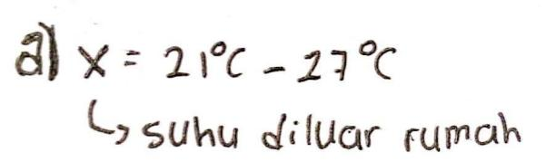
Figure 1. Answer to Question Number 1 for High Category Students
Figure 1 shows that students are able to change a story sentence into a mathematical equation, namely x = 21 – 27, where x is the temperature outside the house. This shows that students understand the relationship between concepts and have successfully modeled them into mathematical equations. This is in line with researchPujianti et al., (2023)that students are able to understand mathematical concepts, situations and relationships by arranging problem-solving steps in a sequential and systematic manner can be seen in Figure 2. as follows.

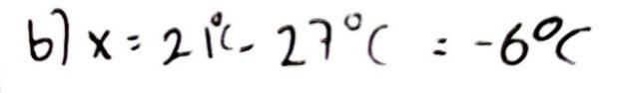
Figure 2. Answers to Question Number 2 for High Category Students
Figure 2 shows that students are able to calculate and give meaning to equations correctly, obtain results and can relate negative numbers to real situations in everyday life. This is in line with research conducted by$x = 21 − 27x = −6$Widodo et al., (2018)that students with high abilities are able to apply special methods in carrying out calculations to solve problems. can be seen in Figure 3. as follows.

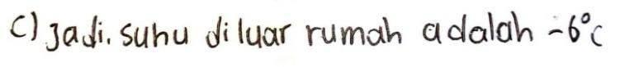
Figure 3. Answer to Question Number 3 for High Category Students
Figure 3 shows that students are able to draw conclusions from the results obtained. Students' ability to draw correct conclusions shows that the students understand the meaning of their calculation results. In line with researchThe Nababan & Tanjung (2020)that students with high abilities in the extrapolation indicator are able to make good and accurate conclusions can be seen in Figure 4. as follows.

- Students with Moderate Mathematical Concept Understanding Ability

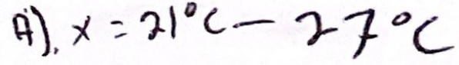
Figure 4. Answer to Question Number 1 for Students in the Medium Category
Based on Figure 4, it can be seen that students in the medium category are able to change a story sentence into its mathematical equation form correctly. This ability shows that students have understood the relationship between concepts and have succeeded in modeling real situations into mathematical symbols. This is in line with the opinionSefiany et al., (2016) that students are able to interpret mathematical ideas appropriately according to mathematical concepts can be seen in Figure 5. as follows.


Figure 5. Answers to Question Number 2 for Students in the Medium Category
Based on Figure 5, it can be seen that students in the medium category have not been able to calculate correctly. Errors occur in the calculation steps, which cause the final answer to not match the results that should be. It is possible that this error occurs because students are not careful in performing integer operations, such as subtraction between two integers. In line with researchNur et al., (2023)Students with moderate ability category often make mistakes in arithmetic operations, with the main causal factor being the lack of understanding of the concept of integer arithmetic operations can be seen in Figure 6. as follows.

Figure 6. Answers to Question Number 3 for Students in the Medium Category
Based on Figure 6, it can be seen that students in the moderate category are good at drawing conclusions, where they have succeeded in conveying the right understanding of the relationship between temperature inside and outside the house. Although the words used by students in concluding are in accordance with the context of the question and describe good understanding, there are errors in the numbers or calculations used to support their conclusions. This is in line with researchThe Last Supper (2019), which states that students with moderate abilities with scores below the KKM can write conclusions, but are less able and less accurate in answering them can be seen in Figure 7. as follows.

- Students with Low Mathematical Concept Understanding Ability


Figure 7. Answer to Question Number 1 for Low Category Students
Figure 7 shows that students have not been able to change information from story problems into the correct mathematical equation. Students seem to have difficulty understanding the relationship between the temperature inside the house and the temperature outside the house which is stated as 27°C lower. This error shows that students have not been able to model real situations into mathematical symbols. In line with the results of Surbakti's research (2024) which stated that students' difficulties in understanding story problems are due to students' lack of ability in using mathematical concepts and students' lack of ability in changing story problems into mathematical sentences can be seen in Figure 8. as follows.

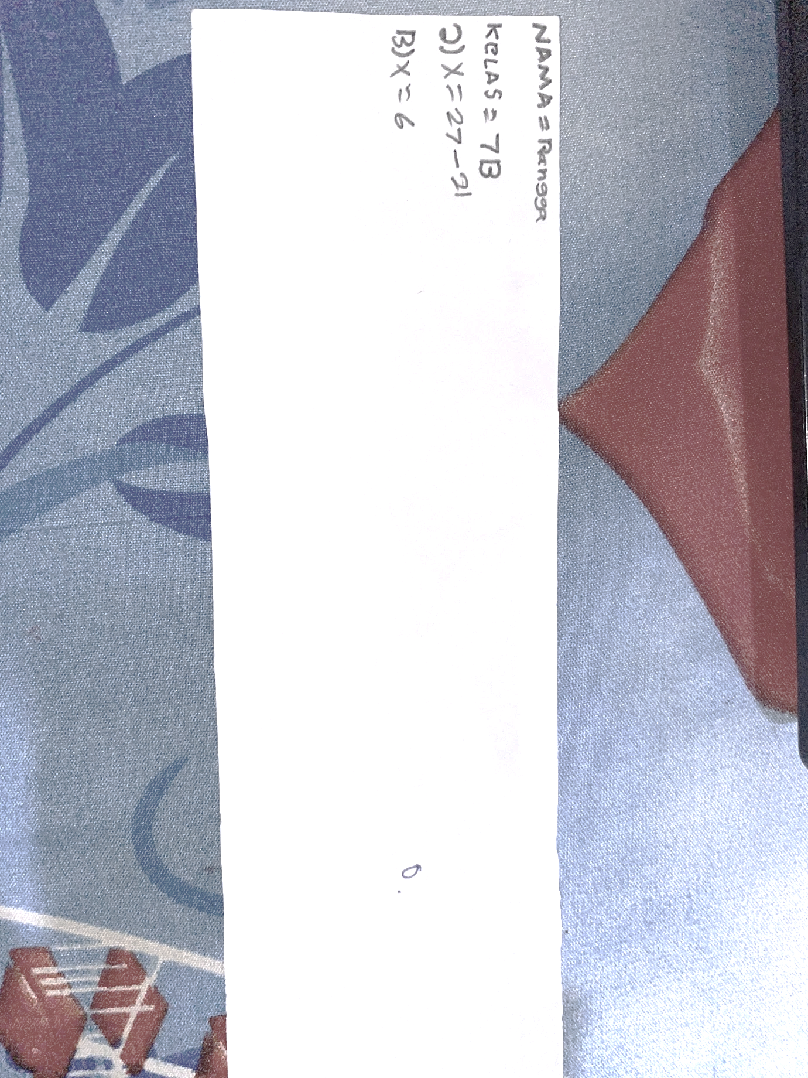
Figure 8. Answer to Question Number 2 for Low Category Students
Figure 8 shows that students do not yet understand the relationship between numbers and are less careful in determining the results of operations, which then has an impact on the process of solving them. In line with research Halawa et al., (2024) that students experience conceptual, principle and operational errors so that these students are in the low category can be seen in Figure 9. as follows.
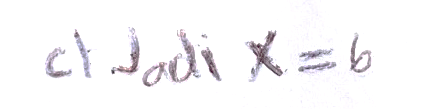
Figure 9. Answer to Question Number 3 for Low Category Students
Figure 9shows that students in the low category have not been able to draw conclusions correctly according to the context of the questions given. This shows that students have difficulty in understanding the concepts used in the questions, especially in interpreting data and existing relationships. One possible cause of this difficulty is a lack of understanding in the previous stages of the learning process, so that students have difficulty in connecting the information provided with concepts that have been previously learned. In line with researchThe Last Supper (2018), students who have poor understanding in the previous stages tend to have difficulty in drawing correct and logical conclusions in solving a mathematical problem.

Conclusion and Suggestions
Based on the results of the analysis of grade VII students' scores at one of the SMPN in Karawang Regency, it was found that students with above average scores had high mathematical concept understanding abilities and met three indicators of understanding, namely translation, interpretation, and extrapolation. Students with average scores had moderate mathematical concept understanding abilities and generally only met one indicator, namely translation. While students with below average scores had low mathematical concept understanding abilities and did not meet the concept understanding indicators.
To improve students' mathematical concept understanding ability, especially for those who are below average, it is recommended that there be learning interventions that focus more on problem-based approaches and the use of teaching aids to help concretely understand concepts. In addition, more comprehensive formative evaluations need to be implemented to measure not only translation but also interpretation and extrapolation. Further research can be conducted to identify other factors that influence students' low mathematical concept understanding ability and develop more effective intervention strategies.

Reference
Arumsari, W. P. A, & Adirakasiwi. (2023). Students' Mathematical Concept Understanding Ability in Solving Straight Line Equation Problems. Journal of Innovative Mathematics Learning, 6(3), 1257–1268. https://doi.org/10.22460/jpmi.v6i3.17077
Bernard, M., Nurmala, N., Mariam, S., & Rustyani, N. (2018). Analysis of Mathematical Problem Solving Ability of Junior High School Students in Grade IX on Plane Structure Material. SJME (Supremum Journal of Mathematics Education), 2(1), 77–83. https://doi.org/10.46799/jst.v4i2.689
Buyung. (2021). Analysis of Concept Understanding Ability Profile. Journal of Mathematics Education and Science, 7(1), 29–34.
.Cahani, K., Effendi, K. N. S, & Munandar, D. R (2021). Students' Mathematical Concept Understanding Ability Reviewed from Learning Concentration on Basic Statistics Material. Innovative Mathematics Learning, 4(1), 215–224. https://doi.org/10.22460/jpmi.v4i1.215-224
Halawa, N., Telaumbanua, Y. N., Zega, Y., & Mendrofa, R.N. (2024). Students' Errors in Solving Mathematics Problems Based on the Newman Method. Jurnal Suluh Pendidikan, 12(1), 51–63.
Kartika, Y. (2018). Analysis of Students' Mathematical Concept Understanding Ability in Grade VII on Algebraic Form Material. Tambusai Education Journal, 3(1), 6–11. https://doi.org/10.35706/rjrrme.v3i1.12075
Kartikasari, R. (2017). Analysis of Students' Difficulties in Solving Mathematical Story Problems in Junior High School Students. Thesis Muhammadiyah University Of Surakarta, 11(1), 92–105.
Latumapina, M., Laamena, C. M., & Ayal, C. S. (2024). Grade VII Junior High School Students on Set Material. Unpatti Mathematics Education Journal, 5(1), 57–68.
Nababan, S. A., & Tanjung, H. S. (2020). Analysis of Students' Ability in Understanding Mathematical Concepts in the Material of Three-Variable Linear Equation Systems. Genta Mulia: Scientific Journal of Education, 13(2), 354–364. https://doi.org/10.30598/jpmunpatti.v5.i1.p57-68
Nilasari, D. (2019). Analysis of mathematical concept understanding ability through solving quadratic equation math problems in class X of SMA Negeri 1 Pebayuran. SESIOMADIKA (Posiding of the National Seminar on Mathematics and Mathematics Education), 4(3), 673–679. https://doi.org/10.33650/trilogi.v4i3.6217
Rahmawati, N. S., Bernard, M. & Akbar, P. (2019). Analysis of Mathematical Communication Skills of Vocational High School Students on the Material of Two-Variable Linear Equation Systems (SPLDV). Journal On Education, 1(2), 344–352.
Nur, A. F. , Prasetyowati, D., & Ariyanto, L. (2023). Analysis of Students' Errors in Solving Integer Arithmetic Operation Story Problems Based on Watson's Criteria. Imajiner: Journal of Mathematics and Mathematics Education, 5(1), 9–20. https://doi.org/10.26877/imajiner.v5i1.12702
Pancarita, & Zainah. (2019). Analysis of Students' Mathematical Understanding in Solving Story Problems on Functional Composition Material. Journal of Education, 20(1), 79–85.
Pujianti, A., Setiawan, W., & Hendriana, H. (2023). Analysis of Students' Mathematical Communication Skills in Quadrilateral Material Reviewed from Self Directing Learning. Journal of Innovative Mathematics Learning, 6(4), 1431–1440. https://doi.org/10.22460/jpmi.v6i4.18279
Putri, I.C., & Roesdiana, L. (2021). Analysis of Students' Learning Methods in Mathematics Learning. Maju, 8(1), 125–132.
Ramadhani, W. P. (2022). Differences in Mastery of Integer Operation Material of Junior High School Students in Villages and in Cities Using Fast Counting Techniques. Jurnal Abdimas Indonesia, 2(2), 216–222. https://doi.org/10.53769/jai.v2i2.239
Rohmah, S., & Rinaldi, A. (2019). Analysis of Mathematical Communication Ability: The Impact of Emotional Intelligence on Algebraic Arithmetic Operation Material. National Seminar on Mathematics and Mathematics Education, 2(1), 199–210.
Sefiany, N., Masrukan, & Zaenuri. (2016). Mathematical Communication Ability Of Grade VII Students In The Model Info Article Abstract. Unnes Journal of Mathematics Education, 5(3), 227–233. https://doi.org/10.15294/ujme.v5i3.12014
Setiani, N., Roza, Y., & Maimumah. (2022). Analysis of Students' Abilities in Understanding Mathematical Concepts of Probability Material in Junior High School Students. Jurnal Cendekia: Journal of Mathematics Education, 6(2), 2286–2297.
Siregar, N. F. (2021). Understanding of Junior High School Students' Mathematical Concepts Through the Realistic Mathematics Education Approach. Jurnal Cendekia: Jurnal Pendidikan Matematika, 5(2), 1919–1927. https://doi.org/10.25105/bhuwana.v1i2.12536
Siregar, T. N. (2023). The Influence of Puzzle Media on Students' Conceptual Understanding in Mathematics Learning in Grade IV of SDN 100900 Gunung Tua, Padang Bolak District, North Padang Lawas Regency. Thesis, Syekh Ali Hasan Ahmad Addary State Islamic University, 3(1), 1–128.
Sulasih, & Firmansyah, D. (2025). Analysis of the Ability to Understand Mathematical Concepts of Junior High School Students on Cube and Block Material. Journal of Mathematics Education Sigma, 6(1), 14–25. https://doi.org/10.21067/pmej.v2i1.2838
Widiastuti, D. (2023). Utilization of Teaching Aids in Whole Number Learning to Improve Students' Understanding of Mathematical Concepts. Journal of Mathematics Education Innovation, 7(3), 159–172.
Widodo, K., Budiarto, M. T, & Lukito, A. (2018). Profile Of Creative Problem Solving Of Ma Students Reviewed From The Level Of Math Self-Efficacy. Journal of Creative-Innovative Mathematics, 1(1), 11-20. https://doi.org/10.26740/jrpipm.v1n1.p11-18
Yulia, P., Gunawan, R. G., & Nasution, E. Y. P. (2020). The Effect of Problem Based Learning (PBL) Learning Model on Students' Mathematical Concept Understanding Ability. PYTHAGORAS: Journal of Mathematics Education Study Program, 9(1), 55–62.

