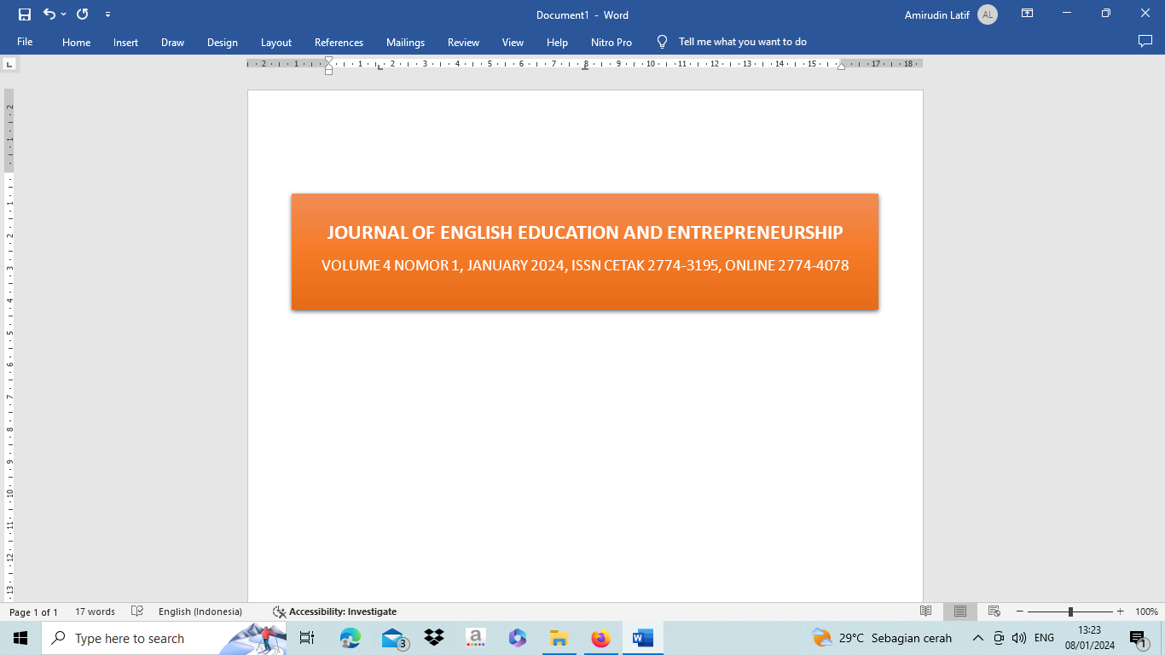
A STUDY ON STUDENTS' DIFFICULTIES IN VOCABULARY MASTERY IN EIGHTH GRADE OF MTS DARUSSALAM ADIJAYA

Fitri Palupi Kusumawati¹, Refai^{3,} Novita Dwi Anggraeni³
Muhammadiyah University of Metro, Metro, Indonesia
Email¹: fitripalupi.1985@gmail.com
Email²: refai@gmail.com
Email³: novitadwianggraeni01@gmail.com

Abstract
This research aimed to analysestudents’ difficulties in mastering vocabularyand the causes of students' difficulties in mastering vocabulary. The Qualitative method was used, with researcher as the main instrument and supporting instruments namely observation, interview and documentation. From the method and data analysis found; 1) Students' difficulties in mastering vocabulary are; pronunciation, the words have many meanings, remembering vocabulary, deficiency of vocabulary, constructing the correct sentence structure, using verbs in simple past tense, understanding the meaning of a new word and writing vocabulary according to the correct spelling. 2) Two factors cause students' difficulties in mastering vocabulary are internal and external. There are seven internal factors; students’ low memory, low interest in learning English, laziness in using dictionaries, lack of motivation, lack of self-confidence, and deficiency of vocabulary. Then, four external factors; inadequate facilities and infrastructure, lack of lighting in the class, lack of learning resources, lack of English speaking activities and teaching methods that are less attractive. Based on the results of this study, it can be concluded that the most students have the same difficulty in mastering vocabulary. Factors that cause this are not only from within the students themselves but also external factors such as the environment around the students.

Keywords: Students’ Dfficulties, Vocabulary Mastery

INTRODUCTION
Expanding vocabulary is one of the critical aspects of learning a foreign language. One needs to know how to utilize their vocabulary appropriately and have a sufficient vocabulary to speak effectively in a foreign language. (Sadiku, 2015) state that vocabulary is one of the inseparable components of language development reading, listening, speaking, and writing is four language skills that must be successfully combined to master English vocabulary.

Critical elements of learning a foreign language often include vocabulary knowledge and competency. One needs an extensive vocabulary and an understanding of how to utilize it correctly to communicate better in a foreign language. There are numerous reasons that language learning is essential. The researcher start to recognize the languages spoken by us soon after our birth, and later we learn to construct these languages on our own (Webb & Nation, 2017). Vocabulary mastery is considered significant in the process of language acquisition or the expansion of individual talent in the language that is regulated.
To know the students' difficulties in mastering vocabulary, researcher first surveyed students' English scores with English teachers and obtained the following data:
Table 1.1 The Scores of Eighth Grade A English Students at Mts Darussalam Adijaya.
No | Score | Number of Students | Classification
1. | 81 –100 | 1 | Excellent
2. | 71 – 80 | 3 | Good
3. | 67 – 70 | 6 | Medium
4.  5. | 60 – 66  < 59 | 6  12 | Low  Failed
TOTAL |  | 28
Source : English Teacher of Eighth Grade A at Mts Darussalam Adijaya.
Based on the table above, many eighth-grade A students at Mts Darussalam Adijaya scored lower than their minimum completeness criteria in their English class. There are still many students who experience difficulties in mastering vocabulary. The minimum completeness criteria that must be completed is 67. Meanwhile, there were 28 students in class VIII A, and it turned out that more students had low KKM scores.
The researcher is interested in analyzing students' difficulties in mastering vocabulary and the factors that cause difficulties in mastering vocabulary. The subjects of this study were students of class VIII A MTs Darussalam Adijaya. Because at MTs Darussalam Adijaya there are many students who have difficulty in mastering English vocabulary. Therefore, the results of this study will be used to suggest an effective teaching approach to improve students' vocabulary mastery. This research will also be useful for identifying problems that students may experience in mastering vocabulary so that solutions can be found to help students master them. Based on the explanation above, the author take the title "ASTUDY ON STUDENTS' DIFFICULTIES IN VOCABULARY MASTERY AT EIGHTH GRADE MTS DARUSSALAM ADIJAYA”
- To find out the difficulties faced by students’ in mastering English vocabulary.
- To find out the causes of students’ difficulties in mastering English vocabulary.

METHOD
Design
The method used in this study is qualitative research. (AK & ZA, 2015) States qualitative research is a form of exploration used to gain an in-depth understanding of human or social phenomena by vividly representing the data collected from informants and observed in the natural environment. According to (Creswell, 2014)qualitative research is an investigation that delves into and comprehends the significance of individuals or groups with social issues. (McCusker & Gunaydin, 2015) State that qualitative methods are employed to answer questions on the “what”, “how”, or “why” of a phenomenon. Gay, Mills, & Airasian as cited in (Sugiyono, 2013)the qualitative research technique includes collecting, analysing, and interpreting non-numerical data, such as narrative and visual data, to understand better the natural phenomena that interest the researcher. This study uses qualitative research, which will produce descriptive data. The reason is that the researcher explores detailed data using the written word to investigate issues more deeply about the subject under study.This research aims to describe students' difficulties in mastering vocabulary and the causes of students' difficulties in mastering English vocabulary at the junior high school level.
The method used in this study is qualitative research. Gay, Mills, & Airasian as cited in (Sugiyono, 2013)the qualitative research technique includes collecting, analysing, and interpreting non-numerical data, such as narrative and visual data, to understand better the natural phenomena that interest the researcher. This study uses qualitative research, which will produce descriptive data. The reason is that the researcher explores detailed data using the written word to investigate issues more deeply about the subject under study.
A bunch of individuals communicating the same characteristics constitutes a population (Creswell, 2012). The population in this study focused on class VIII A students of MTs Darussalam Adijaya during the 2022/2023 academic year. The total number of students in class VIII A is 28 students. To conduct this research, researcher used a non-probability sampling technique, namely snowball sampling. According to (Sugiyono, 2013) Snowball sampling is a sampling technique for data sources, which at first are small in number, gradually become large.
According to (Sugiarto, 2017) the implement employed in the qualitative investigation is the researcher (human instrument).In this research, the researcher is the main instrument and the supporting instruments, namely observation, interview and documentation.
In analyzing the data, the researcher use qualitative research. Miles and Huberman as cited in (Sugiyono, 2013)suggested that qualitative data analysis is an interactive process that proceeds until the data is saturated. This process involves data reduction, data display, and conclusion drawing/verification.

FINDING
The research analysis results using observation instruments, interviews and documentation. The researcher found students' difficulties in mastering vocabulary.
      - Students' difficulties in mastering vocabulary
The first difficulty in students' vocabulary mastery is pronunciation; Pronunciation in English is a challenge English learners face in pronouncing words, sounds or sounds correctly according to the language's pronunciation rules. Some students say pronunciation is complicated; examples in saying the word ate, played, and drank.
The second difficulty in students' vocabulary mastery is remembering; remembering and memorizing vocabulary is challenging for students. Because it is difficult to remember English vocabulary, which makes students' understanding of vocabulary less extensive, it is very difficult for students to understand the teacher's explanation in class.
The third difficulty is words with many meanings, or homonyms, which are words that are spelt or pronounced the same but have different meanings. Students feel confused about choosing the correct meaning in a particular context when they encounter words that have more than one meaning. Vocabulary that has more than one meaning can cause errors in understanding. For example, Right (benar) - Is this the right answer? and Right (kanan) - turn right in the next alley.
The fourth difficulty is in constructing the correct sentence structure. Errors in sentence structure can hinder practical understanding and communication. Students experience difficulties in choosing and arranging words into sentences. Students state that English has a different structure from the student's mother tongue. This difference can lead to difficulties understanding how English words should be arranged and related.
The fifth difficulty is writing words with the correct spelling. Writing English words with correct spelling is one of the challenges students face when they have to master vocabulary. In English, some words are spelt differently but pronounced the same way, and vice versa. This difference between spelling and pronunciation can confuse students and make it difficult for them to remember words correctly.
The sixth difficulty is using the verb in the simple past tense. Students have difficulty in using verbs 1 and 2, including irregular verbs. Some irregular verbs have very different phonetically distinct Verb 1 and 2, so the relationship between Verb 1 and 2 is unclear. For example, "go" (Verb 1) changes to "went" (Verb 2) and "eat" (Verb 1) changes to "ate" (Verb 2). This limitation makes it difficult for students to correctly remember and use these verbs.
The seventh difficulty is understanding the meaning of a new word. Students cannot understand words they have never encountered before. As said, students often have difficulty understanding new vocabulary and feel confused when they find new vocabulary. Students may have difficulty recognizing new vocabulary because they are not used to hearing or pronouncing it correctly.
The eighth difficulty is a lack of vocabulary. Students' limited vocabulary makes it difficult to understand the text or material they read. As said, students experienced difficulties because limited vocabulary made understanding what the teacher explained difficult. This can hinder their ability to convey ideas correctly.
      - The Cause of Students' difficulties in mastering vocabulary
The research analysis results using observation instruments, interviews and documentation. The researcher found there are two factors cause students' difficulties in mastering vocabulary: internal and external.
  - Internal factors
The first cause of students’ low memory; students' memory of English vocabulary is often weak. Students feel that their low memory makes them miss lessons because they do not understand every material the teacher explains. Student memory or memory has a limited capacity.
The second cause of student difficulties is the low interest in learning English. Lack of student interest in English lessons because they do not like English lessons and do not understand the material explained by the teacher. According to them, English is complicated. students who do not have a strong interest in English are less motivated to learn new vocabulary or use the vocabulary they have learned.
The third cause is laziness in using the dictionary. Students are lazy to use a dictionary when they find unknown vocabulary, as the researchers found when they observed that students were lazy to open a dictionary because they thought it was outdated to use a dictionary.
The fourth cause is a lack of motivation. Students need more motivation to learn English, and the researcher saw at the time of observation that students were less enthusiastic when learning took place. Students revealed during interviews that the reason was that they were lazy to study and lazy to do homework. Students are less enthusiastic about learning English Because students learning motivation is lacking, and they do not invest enough time and effort to broaden their knowledge.
The fifth cause is a lack of self-confidence. Students who lack self-confidence feel afraid or doubtful about using the vocabulary they are learning, as expressed by students that they feel less confident; so far, students are always afraid of making mistakes because they feel they are not proficient in English, and this self-confidence makes students not progress.
  - External Factors
External factors are caused by inadequate facilities and infrastructure. From the results of observations made by researchers in the classroom, the condition of a hot room without a fan is very influential in the learning process, which results in students losing focus when learning takes place because students feel hot.
Furthermore due to lack of lighting in class, poor lighting can interfere with students' concentration levels, resulting in difficulties in absorbing information. Inadequate lighting can affect the ability to focus on tasks due to visual discomfort, inadequate lighting can distract students, and learning takes place ineffectively.
Lack of learning resources. Findings obtained by researchers when observing students have difficulty if their access to English learning resources is limited. Lack of adequate textbooks, dictionaries, audio materials, or online resources can limit students' opportunities to expand their vocabulary.
Also is lack of English speaking activities. From the observations that the researchers made, no activities supported students to use English in class, such as dividing groups for discussions, presentations and playing games using English. The absence of supporting activities makes it difficult for students to practice their vocabulary because they are not used to communicating in English.
The last teaching methods that are less attractive, learning methods that are monotonous and less interesting, can cause students' interest and motivation to decrease. Students who are not interested or motivated in the learning process tend to participate less and are reluctant to assimilate new information, including vocabulary.
DISCUSSION
In comparing the results of this study and previous research regarding students' difficulties in mastering vocabulary, the researcher found several differences and updates from previous research. In the results of the previous research, they only stated significant difficulties, not comprehensively, and the context of their research differed from those conducted by researchers. Their research did not refer to the student's difficulties in mastering vocabulary. In distinction, this research looked for difficulties in mastering vocabulary in students so they could look for the root of the problem so that further researchers could find a solution. The results of the research that researchers have done that students have difficulty in pronunciation, the words have many meanings, remembering vocabulary, constructing the correct sentence structure, using verbs in simple past tense, deficiency of vocabulary, understanding the meaning of a new word and writing vocabulary according to the correct spelling.
Based on the experts above, this study has many things that are up to date and complement the above research because this study found that there were several causes of students' difficulties in mastering vocabulary, such as students’ low memory, low interest in learning English, laziness in using dictionaries, lack of motivation, lack of self-confidence, and deficiency of vocabulary, inadequate facilities and infrastructure, due to lack of lighting in class, lack of learning resources, lack of English speaking activities and teaching methods that are less attractive.

CONCLUSION
Based on the result of data analysis, the researcher can conclude students' difficulties in mastering vocabulary are pronunciation, the words have many meanings, remembering vocabulary, deficiency of vocabulary, constructing the correct sentence structure, using verbs in simple past tense,understanding the meaning of a new word and writing vocabulary according to the correct spelling.
Then, there are two factors cause students' difficulties in mastering vocabulary are internal factor and external factor. There are five internal factors: students’ low memory, low interest in learning English, laziness in using dictionaries, lack of motivation, and lack of self-confidence. Then four external factors, namely inadequate facilities and infrastructure, due to lack of lighting in class, lack of learning resources, lack of English speaking activities and teaching methods that are less attractive.

REFERENCES
Anisa, I. (2016). The Vocabulary Mastery of the second Semester Students of Widya Dharma University in academic Year 2015/2016. Magistra, 98, 60–70.
Anwar, Y. T. (2021). The EFL students’ difficulties in discovering the meaning of new words in learning vocabulary at SMAN 1 Gedangan Sidoarjo. UIN Sunan Ampel Surabaya.
Baskarani, S. N. (2016). The Teaching of English Vocabulary (A Case Study at the Seventh Grade Students of MTs Negeri 2 Jakarta). Pages: 123.
Berthier, M. L. (2022). Language testing. In Transcortical Aphasias. https://doi.org/10.4324/9781315784717-2
Creswell, J. W. (2012). Educational research: planning. Conducting, and Evaluating, 260(1), 143.
Dakhi, S., & Fitria, T. N. (2019). The Principles and the Teaching of English Vocabulary: A Review. JET (Journal of English Teaching), 5(1), 15. https://doi.org/10.33541/jet.v5i1.956
Herwiana, S. (2015). A Study of Vocabulary Learning for Young Learners at a Private English Course. 3.
MAISYAROH, S. (n.d.). THE ANALYSIS OF STUDENTS’ABILITY IN MEMORIZING ENGLISH VOCABULARIES AT THE STATE JUNIOR HIGH SCHOOL 4 KAMPAR.
Sadiku, L. M. (2015). The Importance of Four Skills Reading, Speaking, Writing, Listening in a Lesson Hour. European Journal of Language and Literature, 1(1), 29. https://doi.org/10.26417/ejls.v1i1.p29-31
Sugiarto, E. (2017). Menyusun proposal penelitian kualitatif: Skripsi dan tesis: Suaka media. Diandra Kreatif.
Sugiyono, D. (2013). Metode Penelitian Kuantitatif, Kualitatif, dan Tindakan.
Xiao, Z. (2019). Study on Senior High Students’ Perceptions of English Grammar Learning and Pedagogic Implications -----Within the Domain of English Key Competences. 311(Ecss), 297–302. https://doi.org/10.2991/ecss-19.2019.60

